23.49: a)
b) 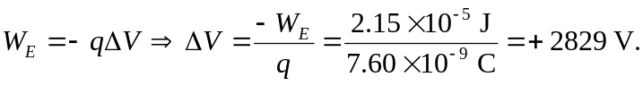 So the initial point is
–2829 V with respect to the final point.

c) 